**DOKUMEN** **KEY PERFORMANCE**

Faiq Maulana

|  |  |  |
| --- | --- | --- |
| No | Job Description | Performance |
| 1 | Membuat Template Website | 10% |
| 2 | Membuat Proposal | 20% |
| 3 | Penguji Website | 10% |

Muhammad Ivan Fadhilah

|  |  |  |
| --- | --- | --- |
| No | Job Description | Performance |
| 1 | Programmer Website | 10% |
| 2 | Create Database | 100% |

Sandy Nur Dwi Satrio

|  |  |  |
| --- | --- | --- |
| No | Job Description | Performance |
| 1 | Analis Website | 10% |
| 2 | Dokumentator | 10% |

Malang, 24 Februari 2021

Disetujui oleh:

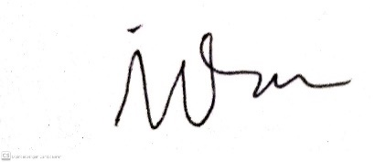

(Faiq Maulana ) (M. Ivan Fadhilah) (Sandy Nur Dwi Satrio)